**MAIN COMBUSTION CHAMBER DESIGN**

**Closed Expander Cycle**

The closed expander cycle refers to the cycle where all propellants that enter into the engine leave by going through the throat of the main combustion chamber thus yielding the greatest chemical efficiency.

The closed expander cycle is one of the simplest engine cycles.

**Closed Expander Cycle Illustration**

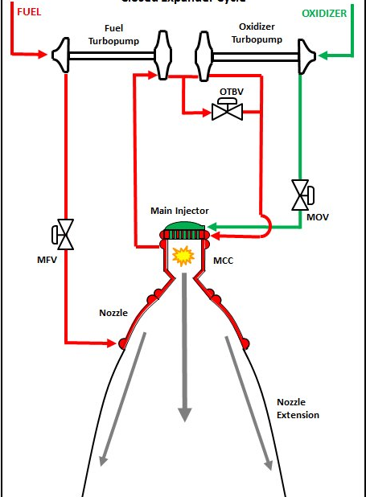

**Operation of the closed expander cycle**

The fuel and oxidizer come in from the stage and are passed through pumps to raise their pressure. In the fuel section, the pump outlet is routed through the Main Fuel Valve (MFV) to the nozzle and to the Main Combustion chamber for cooling purposes. (To cool the combustion chamber).

The combustion chamber is cooled first then the warmer fuel is used to cool the nozzle since there are higher temperatures in the combustion chamber as compared to those in the nozzle. The discharge from this, with energy picked up in the form of heat is used, to turn the turbines.

The oxidizer turbine bypass valve (OTBV) shown in the diagram is a means for controlling mixture ratio by moderating the power to the oxidizer turbine. By bypassing the turbine, the output of pressure from the pump is lower thus a lower oxidizer pressure. In the event that we have only one mixture ratio, an orifice to set and maintain a particular pressure is used instead of the bypass valve.

The turbines being driven by the warm fuel, which after driving the turbines is fed into the main injector and then into the combustion zone.

For the oxidizer side, the output from the oxidizer pump is fed directly through the Main Oxidizer valve into the combustion zone.

Within the Main Combustion Chamber we have the combustion of the propellants which in turn causes the release of energy, the generation of high-velocity combustion products, and the expulsion of these products through the sonic Main Combustion Chamber (MCC) throat and out the supersonic nozzle.  This is what gives us thrust.

**Pros and Cons**

* The closed expander cycle is the simplest engine cycle, thus makes it one of the easiest to fabricate and design.

This simplicity is both a strength and a limiting factor of the cycle. Since all the fuel is being pushed to the cooling of the engine and finally being injected to the combustion chamber, it results in pressure drops thus the turbines lack adequate power to supply to the pumps**. The result of this is that the chamber pressure can not be very high as desired**. Hence the throat of the Main Combustion Chamber is relatively large to allow the fuel to pass through and the expansion ratio of the nozzle is limited by size and weight. All this may limit the amount of thrust.

* Ideally, from a source on the internet, the closed expander cycle is suitable and more practical when the thrust required is kept well below 35,000 pounds-force (**155,687 Newtons**) 🡪 155kN

To address the shortcomings of the closed expander cycle are a variety of modifications of the same, as shown below:

* Closed Split Expander
* Closed Dual Expander
* Closed Dual Split Expander
* Open Expander Cycle

In these cycles, the fuel (or and oxidizer) are used to drive the turbines to power the pumps and cause the injection of the fuel and oxidizer into the combustion chamber. This makes it efficient in that we do not require an external pump e.g. nitrogen. However, the feasibility of this is yet to be fully examined by the team.

The Open Expander Cycle is also a quite efficient cycle that is cost effective. The Open Expander Cycle is described below;

**Open Expander Cycle**

The greatest difference between the Open Expander Cycle and the Closed Expander Cycle is that the working fluid driving the turbines is dumped into the downstream portion of the nozzle i.e. at the exhaust region of the nozzle. This on its own is an inherent inefficiency of the cycle. However, despite the loss of efficiency, we gain a greater pressure range. Since we do not have to stuff the turbine bypass into the combustion chamber, we can make the chamber pressure much higher. Practically, two to three times higher than in a simple closed expander cycle.

This in turn allows for a very small throat and this gives the opportunity for a very high nozzle expansion ratio within reasonable size and structural weight limits.

The very high expansion ratio implies more exhaust acceleration and, in this manner, we get back all the same performance as in a closed cycle despite the propellant dump.

A pictorial illustration of the open expander cycle is shown below;

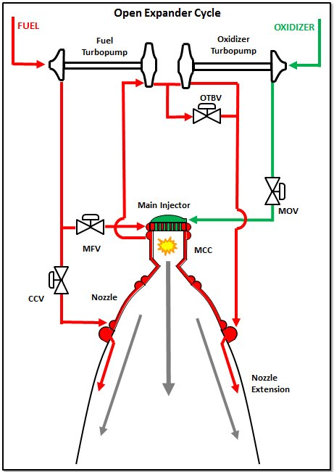

**NOZZLE DESIGN**

Objectives

1. To establish the most efficient nozzle geometry that will maximize pressure while minimizing pressure drops.
2. To integrate cooling system to the nozzle and combustion chamber
3. To develop a CAD model of the nozzle with cooling and combustion chamber
4. To come up with ANSYS/ABAQUS/COMSOL Multiphysics simulations

Theory

* **Introduction**

A nozzle is a venturi device that, given sufficient upstream pressure and flow conditions, can result in choked flow at its throat.

Nozzles have a variety of uses such as to accelerate flow for atomization of liquid phases, as part of jets to increase kinetic energy and to propel gas in rocket engines, in natural gas production wells to accelerate gas velocity, among many others.

The nozzle geometry plays a very crucial role in achieving optimum results of the whichever application is being desired.

Nozzles have 3 main sections; the converging section, throat and the diverging section as shown in the image below.

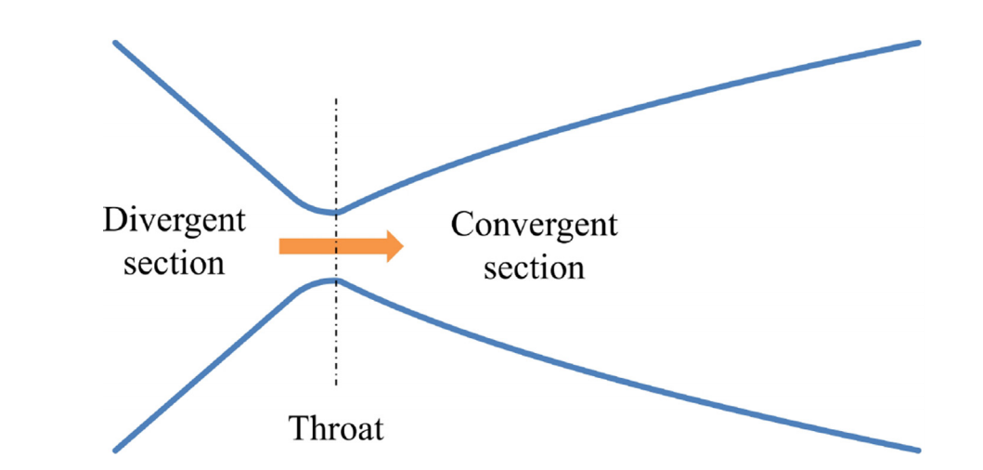

The region with the smallest diameter is referred to as the throat, that can either be a single point or it can be elongated. The upstream section of the throat is known as the converging section and the section downstream of the throat is known as the diverging section.

The purpose of using a nozzle is to accelerate flow and to achieve critical / sonic conditions (Choked flow) at the throat.

An optimum nozzle geometry is one where choked flow is achieved at a larger critical pressure ratio value compared to other nozzle geometries. (minimizing the pressure drops across the nozzle).

* **Design**

According to a review of nozzles implemented in industries, nozzles can be classified into two;

* Conical nozzle (Converging-diverging nozzle)

Has a downward tapering linear inlet area that reduces in cross sectional area until the throat diameter has been reached, and then an outward tapering linear outlet area where the cross-sectional area increases along the profile. The tapering angle at the inlet is called the **converging angle (β).** The tapering angle at the outlet is called the **divergence** **half angle (α)**. The diameter of the smallest part of the nozzle is known as the **throat diameter (Dt).**

This is shown below;

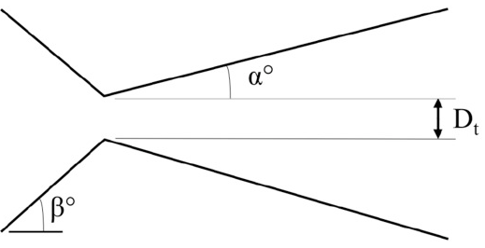

The cone half angle; **(α)** should not exceed **15°** degrees to avoid nozzle internal flow losses. According to research by Barber, the value of cone divergence should be **between 2 and 12 degrees** (Barber and Schulthesis, 1967).

The value of the converging angle has an almost definitive value of 45 degrees. Varying this angle has barely any effect. However, a different shape of the converging angle may have an effect on the pressure drops on the nozzle.

1. **Converging – Diverging Nozzle**: This is a basic de Laval nozzle without an elongated throat that is used in many applications such as steam turbines and rocket engines.
2. **Modified Converging** – **Diverging Nozzle**: The design of this nozzle includes an elongated throat length. In the technical report ‘Acceleration of liquids in two phase nozzles’ by NASA, it was determined that the throat length had an impact on the performance of the nozzle (Elliot and Weinber, 1968).
3. **Dual Converging Nozzle**: The design for a dual converging nozzle was obtained from a patent of a liquid gas injector in the industry of jet technology (Popov, 2002). It has two subsequent converging sections with decreasing converging angle.

Besides the converging nozzle types, a variety of nozzle geometries exist. Parabolic nozzles also are an option for the type of nozzles.

These are shown below;

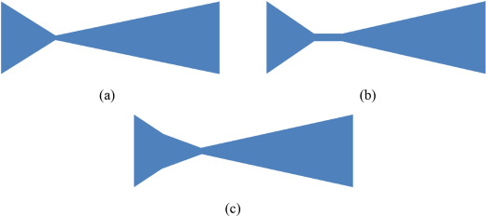

Conical [nozzles](https://www.sciencedirect.com/topics/materials-science/nozzle) – (a) Group 1 nozzle, (b) Group 2 nozzle, (c) Group 3 nozzle.

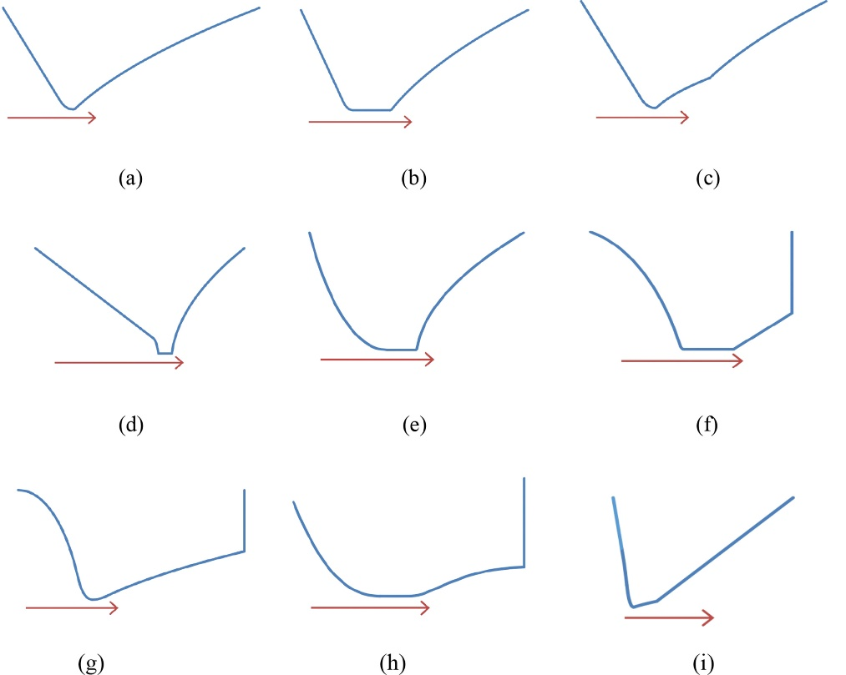

Parabolic [nozzles](https://www.sciencedirect.com/topics/materials-science/nozzle) – (a) Rao nozzle, (b) Modified Rao nozzle, (c) Dual Bell nozzle, (d) Converging Convex nozzle, (e) Converging Concave nozzle, (f) Moby Dick nozzle, (g) ASTAR nozzle, (h) Deich nozzle, (i) LJ nozzle.

The basic design for parabolic nozzles is as shown;

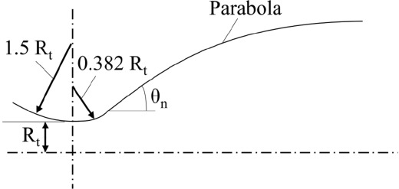

Conclusion

It was established, from experiments conducted on 27 different nozzle geometries divided into two groups – conical and parabolic nozzles, that a smaller diverging angle and absence of an elongated throat resulted in a higher critical pressure ratio.

References

1. [nasa blog](https://blogs.nasa.gov/J2X/tag/main-combustion-chamber/)
2. <https://www.sciencedirect.com/science/article/pii/S2405844018374164#:~:text=An%20optimum%20nozzle%20geometry%20is,compared%20to%20other%20nozzle%20geometries.&text=Almeida%20(2015)%20investigated%20the%20effect,diverging%20section)%20on%20nozzle%20performance.>

**NOZZLE DESIGNS**

* **Design 1**

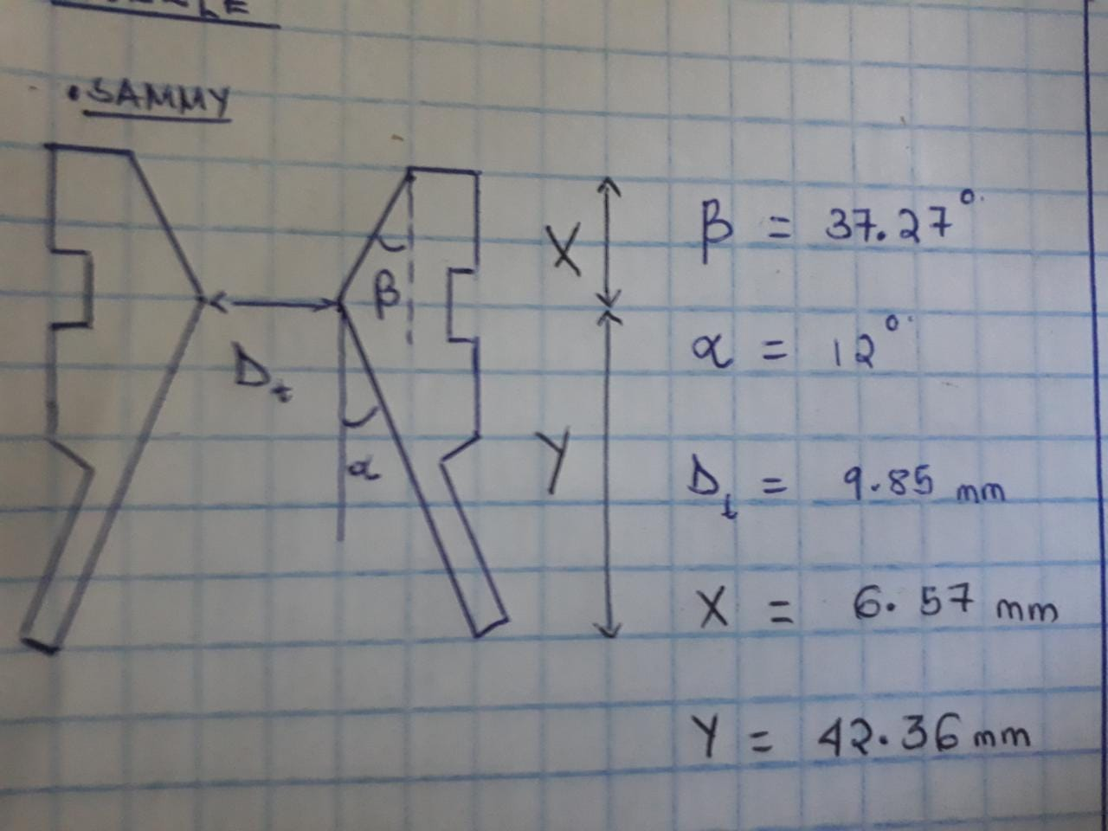

* **Design 2**

